**ST. XAVIER’S COLLEGE**

**(Affiliated to Tribhuvan University)**

**Maitighar, Kathmandu**



**COMPUTER GRAPHICS**

**LAB ASSIGNMENT#5**

**Submitted by:**

Saurav Bajracharya

013BSCCSIT035

**Submitted to:**

|  |  |
| --- | --- |
| **Er. Anil K. Sah** |  |

Lecturer

Department of Computer Science

Date of submission: 21st August, 2015

**Algorithm:**

Step 1. Set X = 0 and Y = R

Step 2. Set P = 1 – R

Step 3. Repeat While (X < Y)

Step 4. Call Draw Circle(Xc, Yc, X, Y)

Step 5. Set X = X + 1

Step 6. If (P < 0) Then

Step 7. P = P + 2X + 6

Step 8. Else

Step 9. Set Y = Y – 1

Step 10. P = P + 2(X – Y) + 1

[End of If]

Step 11. Call Draw Circle(Xc, Yc, X, Y)

[End of While]

12. Exit

**Source Code:**

//---------------------------------------------------------------------------

#include <vcl\vcl.h>

#pragma hdrstop

#include "Unit1.h"

//---------------------------------------------------------------------------

#pragma resource "*.dfm"

TForm1 *Form1;

//---------------------------------------------------------------------------

__fastcall TForm1::TForm1(TComponent* Owner)

: TForm(Owner)

{

}

//---------------------------------------------------------------------------

void __fastcall TForm1::DrawClick(TObject *Sender)

{

int xc,yc,r;

xc=StrToInt(Edit1->Text);

yc=StrToInt(Edit2->Text);

r=StrToInt(Edit3->Text);

int p,x,y;

x=0;

y=r;

Image1->Canvas->Pixels[xc+x][yc+y]=RGB(100,200,200);

Image1->Canvas->Pixels[xc-x][yc+y]=RGB(10,200,100);

Image1->Canvas->Pixels[xc+x][yc-y]=RGB(150,210,250);

Image1->Canvas->Pixels[xc-x][yc-y]=RGB(255,0,0);

Image1->Canvas->Pixels[xc+y][yc+x]=RGB(0,255,0);

Image1->Canvas->Pixels[xc-y][yc+x]=RGB(0,0,255);

Image1->Canvas->Pixels[xc+y][yc-x]=RGB(55,56,211);

Image1->Canvas->Pixels[xc-y][yc-x]=RGB(58,250,158);

p=1-r;

while(x<y)

{

if(p<0)

{

x=x+1;

p=p+2*x+1;

}

else

{

x=x+1;

y=y-1;

p=p+2*(x-y)+1;

}

Image1->Canvas->Pixels[xc+x][yc+y]=RGB(100,200,200);

Image1->Canvas->Pixels[xc-x][yc+y]=RGB(10,200,100);

Image1->Canvas->Pixels[xc+x][yc-y]=RGB(150,210,250);

Image1->Canvas->Pixels[xc-x][yc-y]=RGB(255,0,0);

Image1->Canvas->Pixels[xc+y][yc+x]=RGB(0,255,0);

Image1->Canvas->Pixels[xc-y][yc+x]=RGB(0,0,255);

Image1->Canvas->Pixels[xc+y][yc-x]=RGB(55,56,211);

Image1->Canvas->Pixels[xc-y][yc-x]=RGB(58,250,158);

}

}

//-------------------------------------------

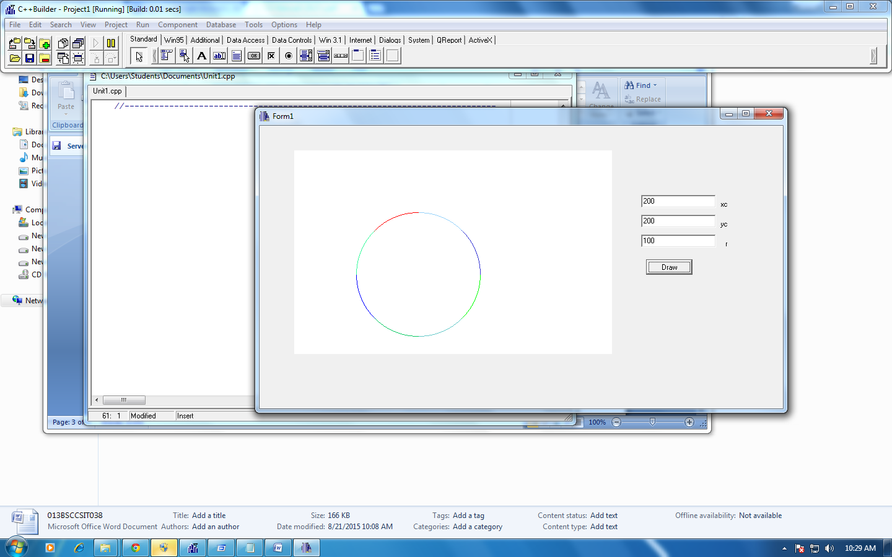**OUTPUT:**

**REFERENCE:**

http://www.eazynotes.com/notes/computer-graphics/algorithms/mid-point-circle-algorithm.pdf